DATA ANALYTICS

ASSIGNMENT-2

G.DEVENDRA REDDY

[gajjalareddy9381@gmail.com](mailto:gajjalareddy9381@gmail.com)

20KH1A0533

**DONUT CHART**

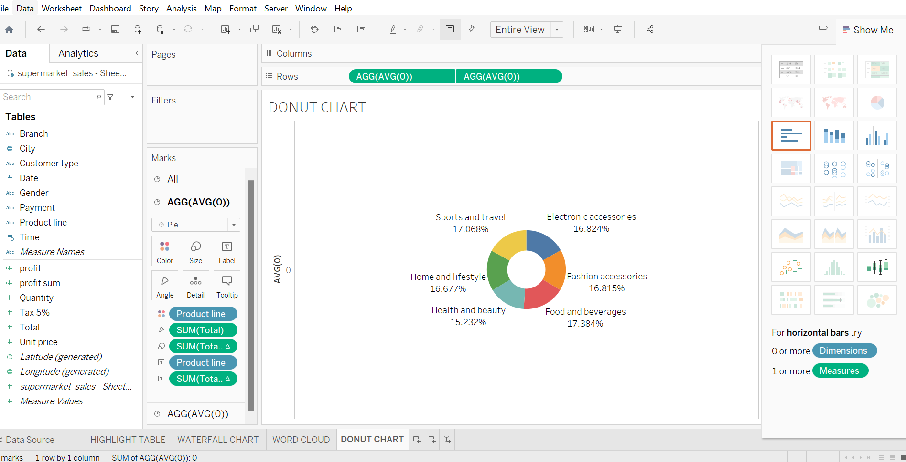

**AREA CHART**

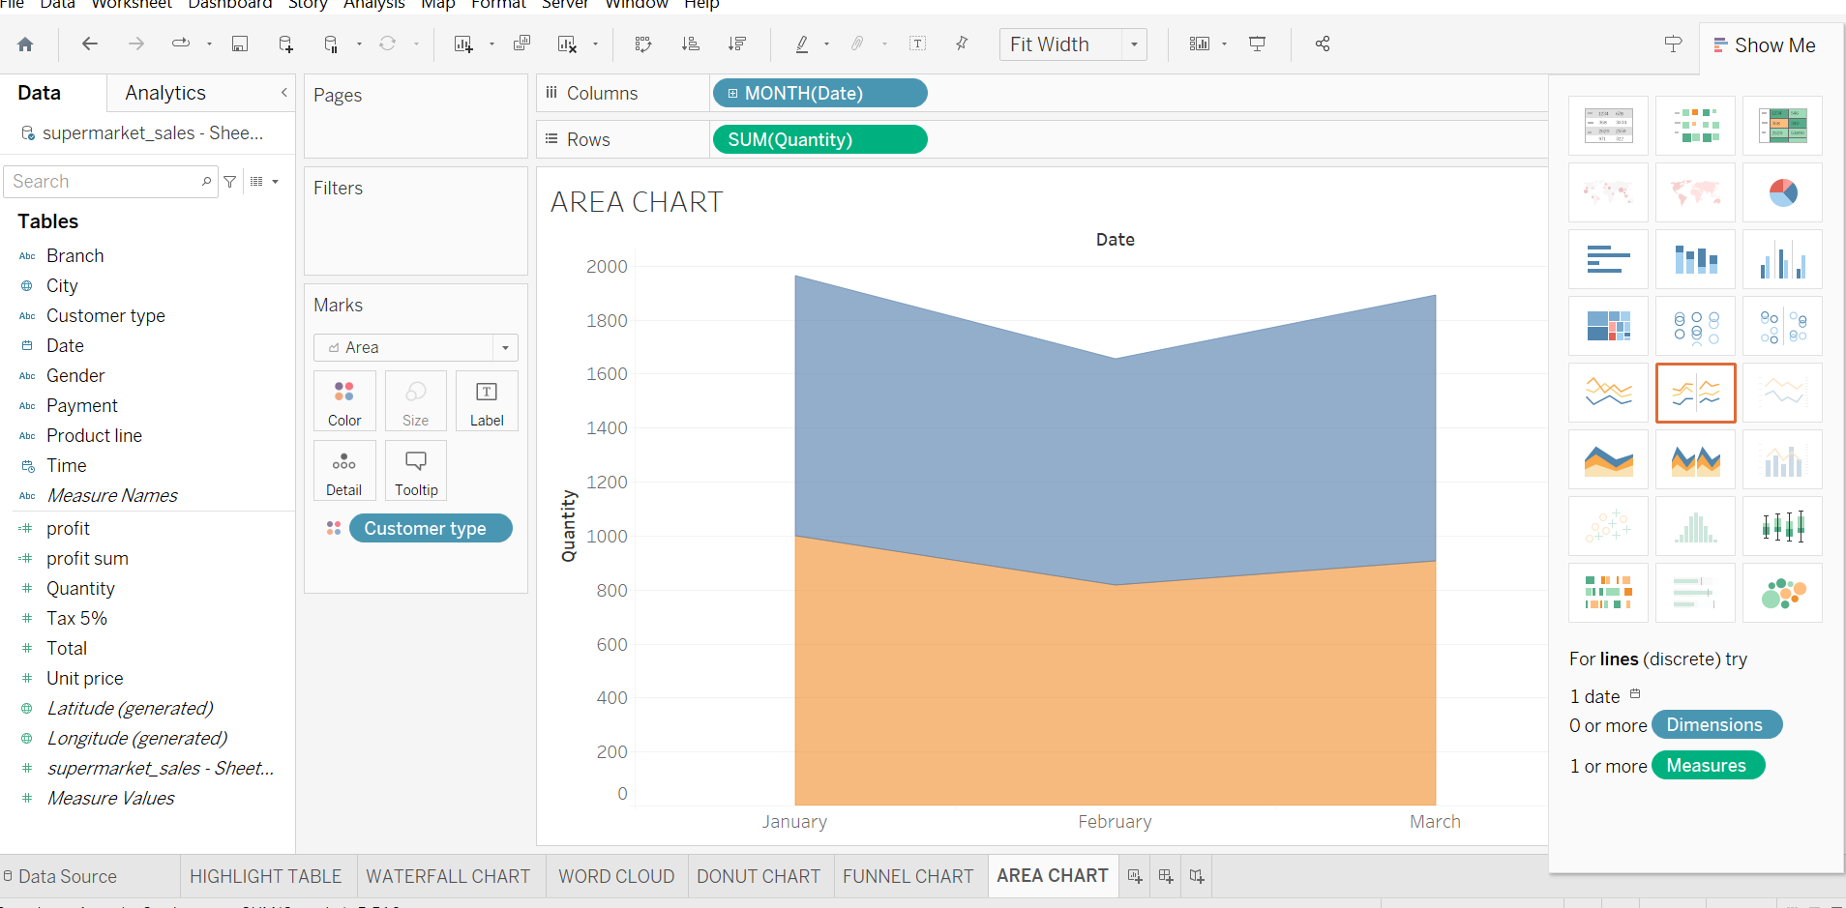

**TEXT TABLE**

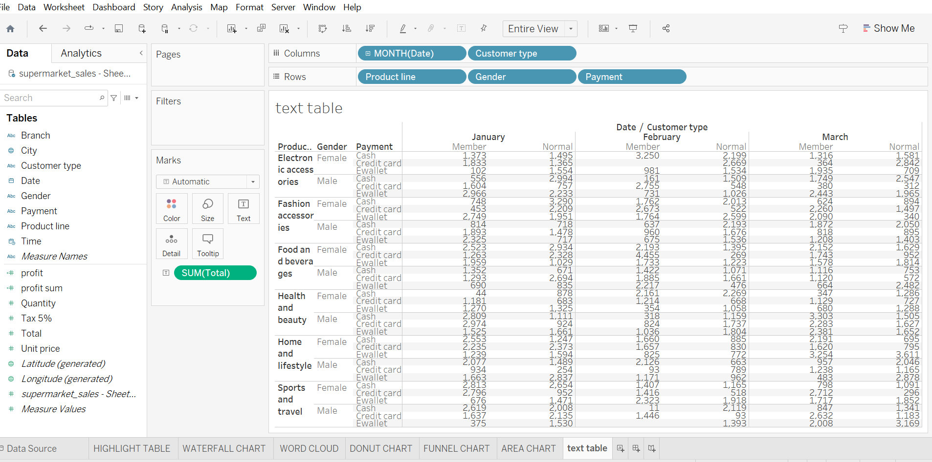

**HIGHLIGHTED TABLE**

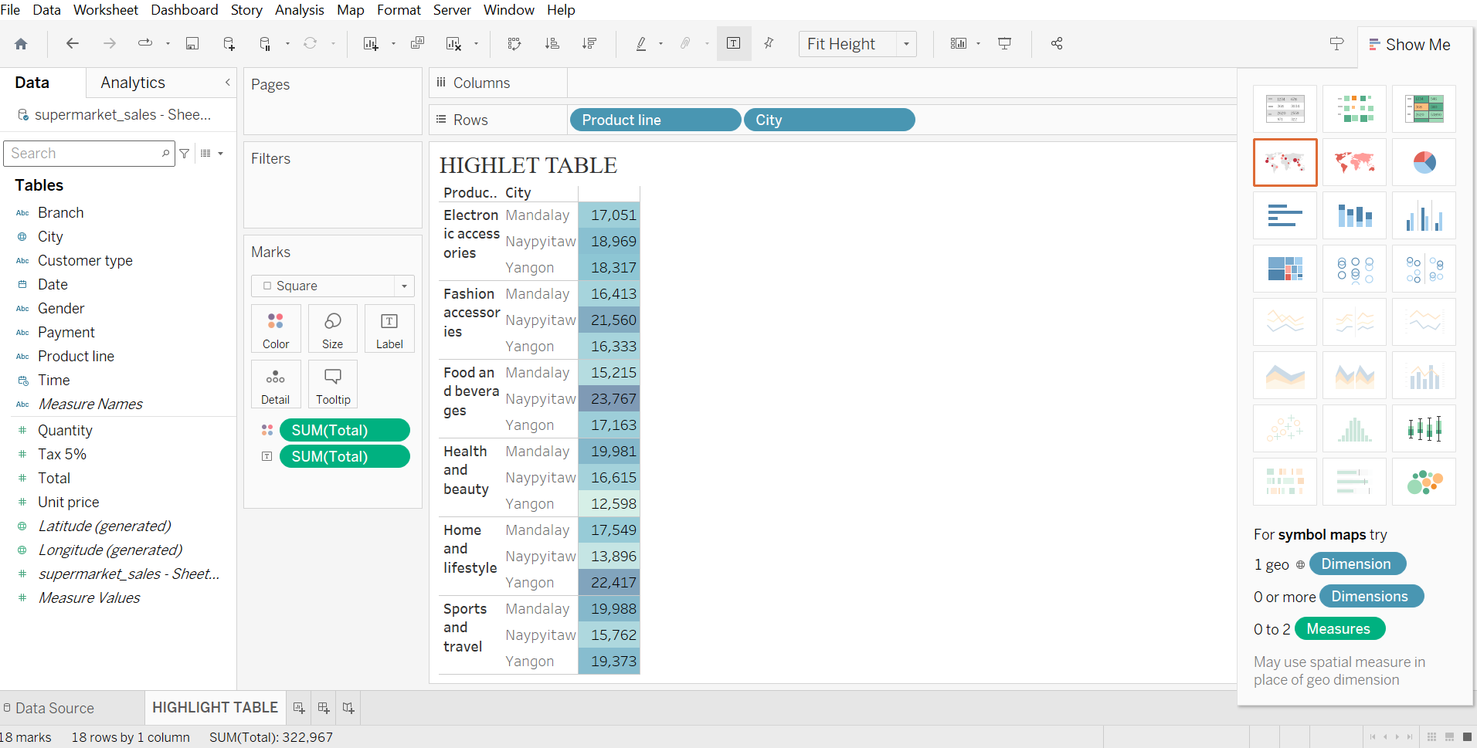

**WORD CLOUD**

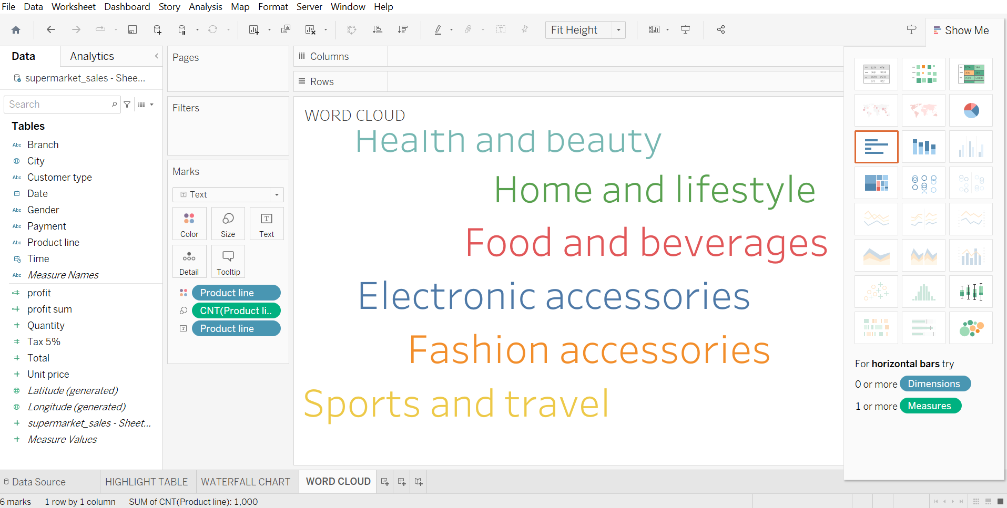

**FUNNEL CHART**

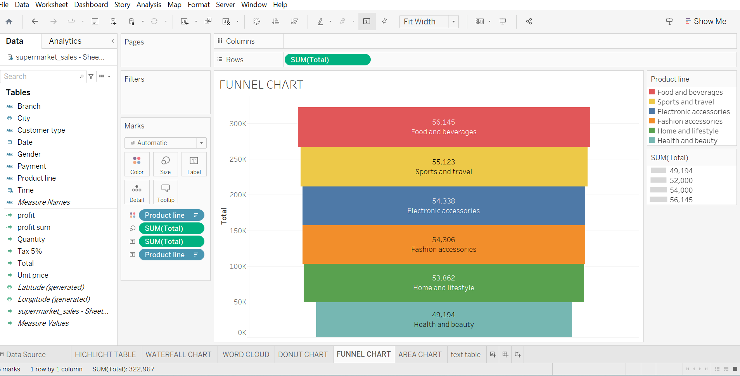

**WATER FALL**

